# IR Remote

An IR (Infrared) remote is a handheld wireless device used to control electronic appliances via infrared light signals.

**Working Principle:**  
It emits modulated infrared light (typically at 38kHz) from an IR LED when a button is pressed. This light is picked up by an IR receiver in the target device.

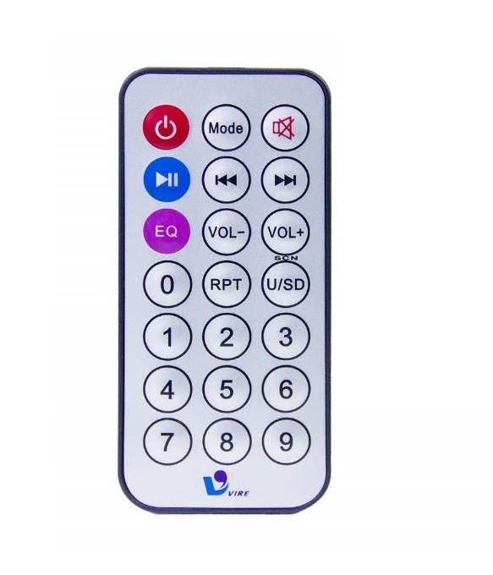**Types**:  
- TV remote  
- Universal remote  
- Custom IR remotes (Arduino compatible)

**Applications**:  
- Remote control for TVs, fans, and ACs  
- DIY projects with Arduino  
- Wireless triggering of circuits

**Advantages**:  
- Wireless control   
- Energy efficient  
- Simple protocol

**Disadvantages**:  
- Line-of-sight required  
- Limited range   
- Prone to interference from sunlight Fig : IR Remote